ANNEX II + III: TECHNICAL SPECIFICATIONS + TECHNICAL OFFER

Contract title: OFFICE PRODUCTS - HYGIENIC MATERIAL SUPPLY p 1 /…
Publication reference: 04/2023/AID012590/08/8

Columns 1-2 should be completed by the contracting authority
Columns 3-4 should be completed by the tenderer
Column 5 is reserved for the evaluation committee
Annex III - the contractor's technical offer
The tenderers are requested to complete the template on the next pages:
- Column 2 is completed by the contracting authority shows the required specifications (not to be modified by the tenderer),
- Column 3 is to be filled in by the tenderer and must detail what is offered (for example the words ‘compliant’ or ‘yes’ are not sufficient)
- Column 4 allows the tenderer to make comments on its proposed supply and to make eventual references to the documentation
The eventual documentation supplied should clearly indicate (highlight, mark) the models offered and the options included, if any, so that the evaluators can see the exact configuration. Offers that do not permit to identify precisely the models and the specifications may be rejected by the evaluation committee.
The offer must be clear enough to allow the evaluators to make an easy comparison between the requested specifications and the offered specifications.

Financial/technical offer

NAME OF THE SUPPLIER:

Pos. | Description of Items | Technical specifications required | Preferred Unit Measure | Unit Measure offered by Supplier | Type of packaging  (box, ream, pack, bag, single piece...) | Quantity contained in each packaging-unit | Financial offer for packaging-unit  RWF  Unit cost with delivery DDP
1 | liquid soap for hands 400ML | 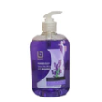 | bottle
2 | bathroom cleaner 1L | 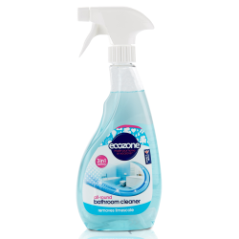 | bottle
3 | Tile cleaner 1L | 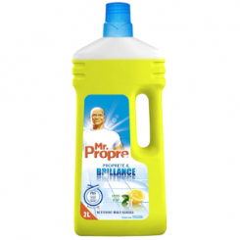 | bottle
4 | window cleaner 750Ml | 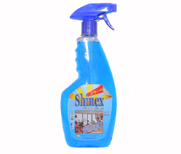 | bottle
5 | Hand sanitizer 100Ml | 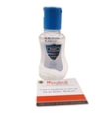 | bottle
6 | Hand sanitizer 500Ml | 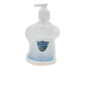 | bottle
7 | face masks | 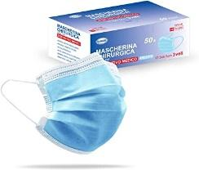 | Box 50pcs
8 | face mask FFP2 | 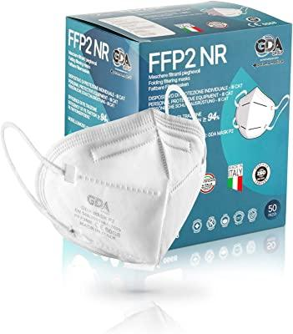 | Box 20 pcs
9 | bottled water 500Ml | 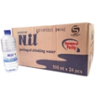 | Box 24 pcs
10 | bottled water 18.9L | 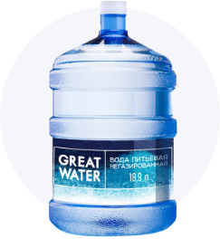 | pcs
11 | Vim washing powder 750Gr | 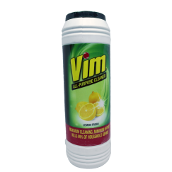 | bottle
12 | floor towel | 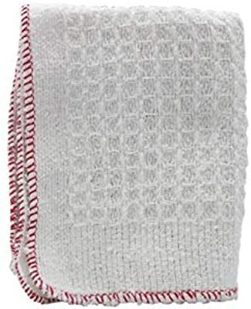 | pcs
13 | broom | 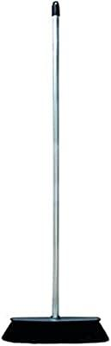 | pcs
14 | mop | 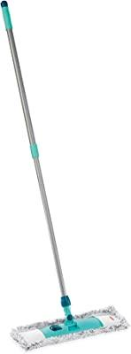 | Pcs
15 | toilet brush | 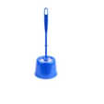 | Pcs
16 | toilete cleaner 500Ml | 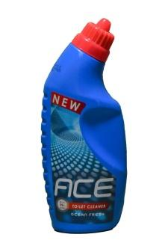 | bottle
17 | light bulb 5W | 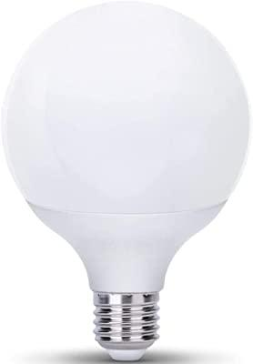 | pcs
18 | light bulb 7W |  | pcs
19 | light bulb 10W |  | pcs
20 | light bulb 15w |  | pcs
21 | instant coffe 200Gr | 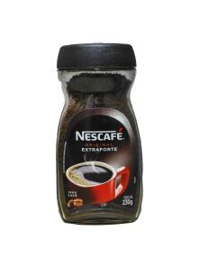 | pcs
22 | instant milk 400Gr | 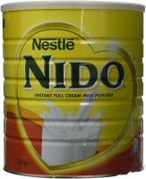 | pcs
23 | tea bags | 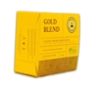 | Box 50 bag
24 | eletric water heater 1L | 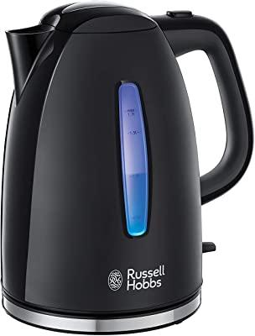 | pcs
25 | water dispenser with cold and hot water | 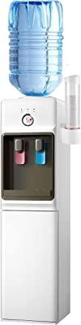 | pcs
26 | glasses | 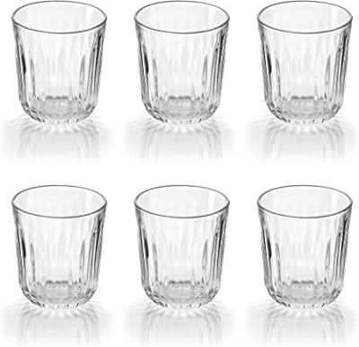 | Box 6pcs
27 | mugs | 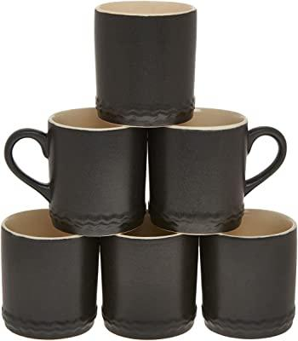 | Box 6 pcs
28 | sugar | 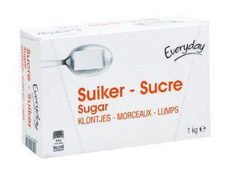 | Box 1Kg
29 | car detergent | 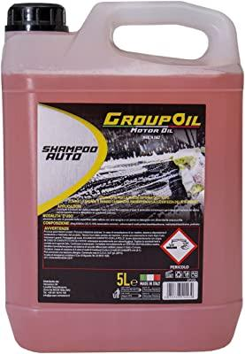 | Bottle 2 L
30 | Kitchen sponge | 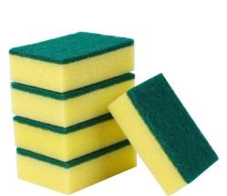 | Pack 5pcs
31 | insect killer | 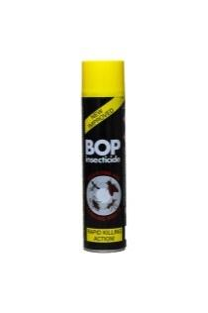 | pcs
32 | rubber gloves | 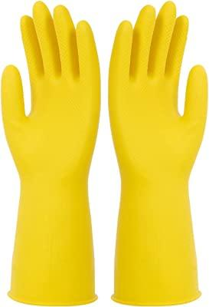 | Pack 1 copie
33 | plastic water bucket 15L | 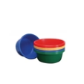 | Pcs
34 | tiolet paper | 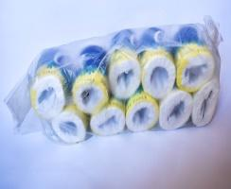 | Pack 10pcs
35 | Plastic bucket 10L | 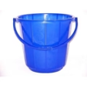 | Pcs
36 | Cock brand | 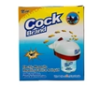 | pcs
37 | Mosquito repellent | 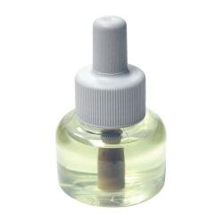 | Pcs
38 | Kitchen serviettes cotton 50x40cm | 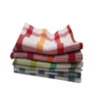 | Pack 5pcs
39 | dish soap 1L | 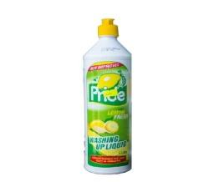 | bottle
40 | Napkins paper | 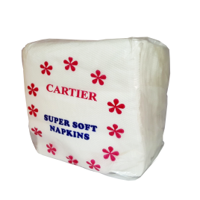 | Pack 100 Napkins
41 | tea spoons | 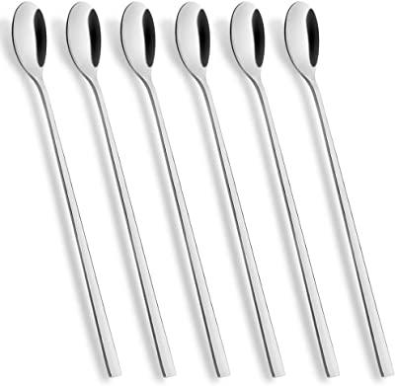 | Pack 6pcs
42 | conteiners 15Cm | 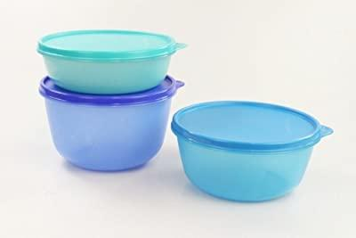 | Set 3 pcs
43 | entrance carpet 90x50 | 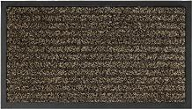 | Pcs
44 | biscuits Akarabo | 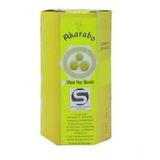 | Pcs
45 | juice 250Ml | 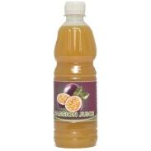 | Pcs
46 | hard soap | 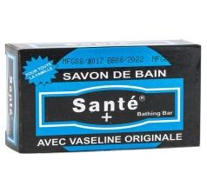 | Box 24 pcs
47 | towel 90x140 | 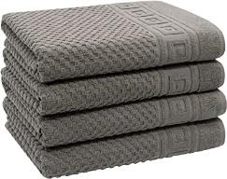 | Pcs
48 | Pad cotex | 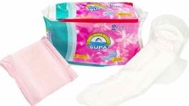 | Box 24 pack
49 | Gel toilette intime | 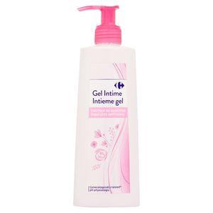 | Pcs
50 | latex gloves | 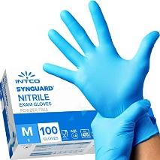 | Box 100pcs
51 | towels 40x60 |  | pcs
 | DELIVERY TIME FROM THE ORDER |  |  |  |  | Days | 2
 | DELIVERY QUANTITY AT THE ORDER |  |  |  |  | % | 100
 | VALIDITY OF THE QUOTATION |  |  |  |  | Days | 365

Done at: by

_______________________
Stamp and signature

