ANNEX II + III: TECHNICAL SPECIFICATIONS + TECHNICAL OFFER

Contract title: Printing Supply p 1 /…
Publication reference: <02/2026/AID013244.12.2 >

Columns 1-2 should be completed by the contracting authority
Columns 3-4 should be completed by the tenderer
Column 5 is reserved for the evaluation committee
Annex III - the contractor's technical offer
The tenderers are requested to complete the template on the next pages:
- Column 2 is completed by the contracting authority shows the required specifications (not to be modified by the tenderer),
- Column 3 is to be filled in by the tenderer and must detail what is offered (for example the words ‘compliant’ or ‘yes’ are not sufficient)
- Column 4 allows the tenderer to make comments on its proposed supply and to make eventual references to the documentation
The eventual documentation supplied should clearly indicate (highlight, mark) the models offered and the options included, if any, so that the evaluators can see the exact configuration. Offers that do not permit to identify precisely the models and the specifications may be rejected by the evaluation committee.
The offer must be clear enough to allow the evaluators to make an easy comparison between the requested specifications and the offered specifications.

Financial/technical offer

NAME OF THE SUPPLIER:

Item number | Description of items | Technical specifications required | Preferred Unit Measure | ESTIMATED QUANTITY* | Unit Measure offered by supplier | Quantity contained in each packaging-unit | AVAILABILITY IN STOCK? YES OR NO |  | PLEASE INSERT DELIVERY TIME FROM PURCHASE PRDER
1 | Roll up banner (80cm x 200cm) | 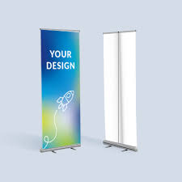 | Piece
2 | Flying banner (250cm) | 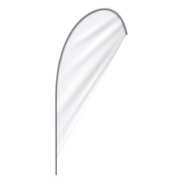 | Piece
3 | Hanging banner | 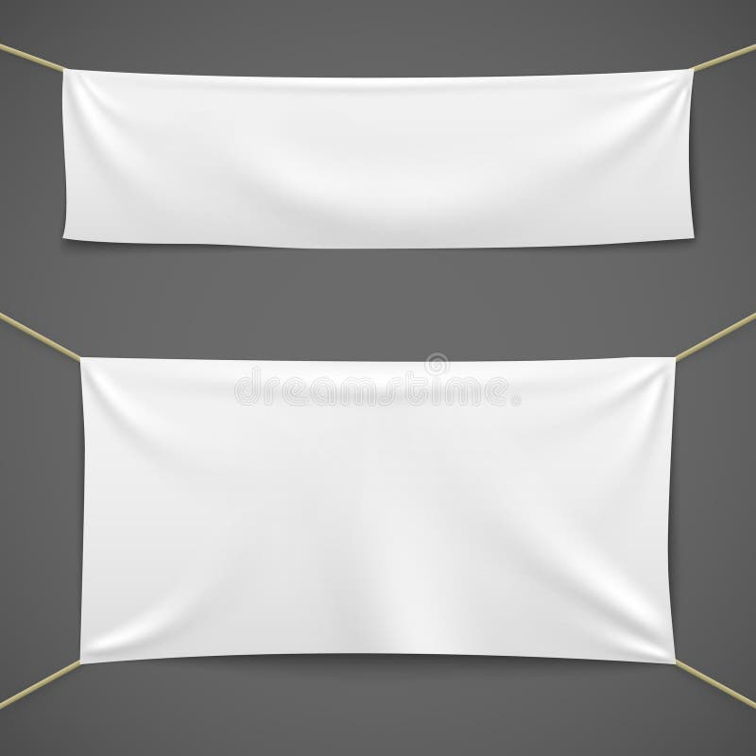 | Piece
4 | Office signboard |  | Piece
5 | Project signboard | 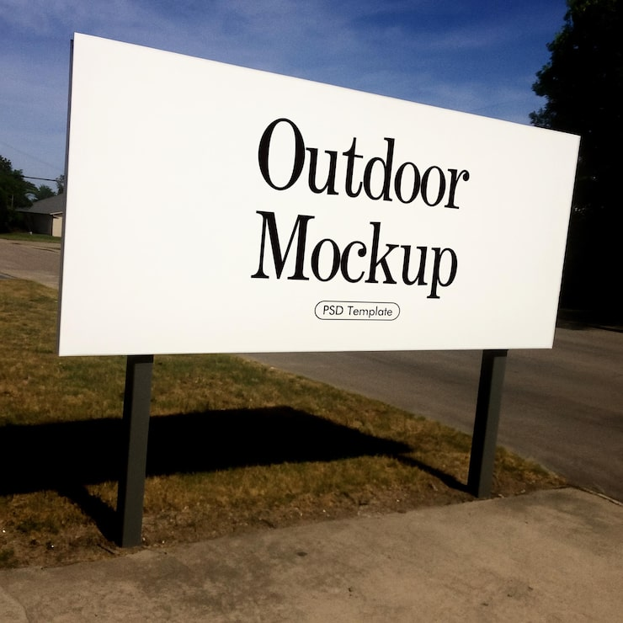 | Piece
6 | Standard business card (8.9cm x 5.1cm) | 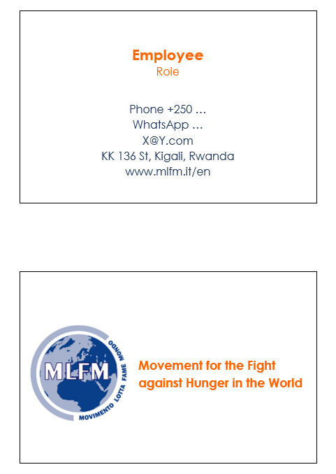 | Piece
7 | Badge with lanyard |  | Piece
8 | Badge | 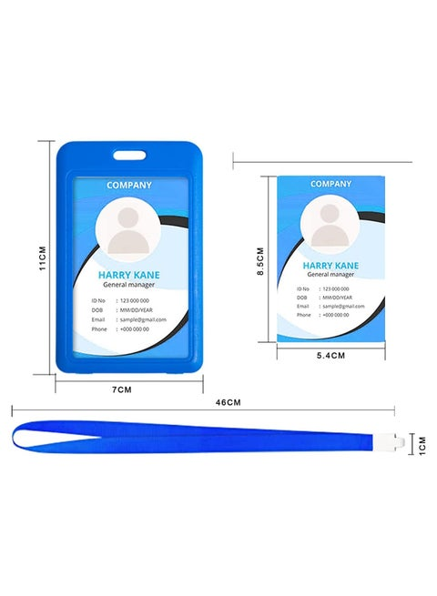 | Piece
9 | Lanyard with logo | 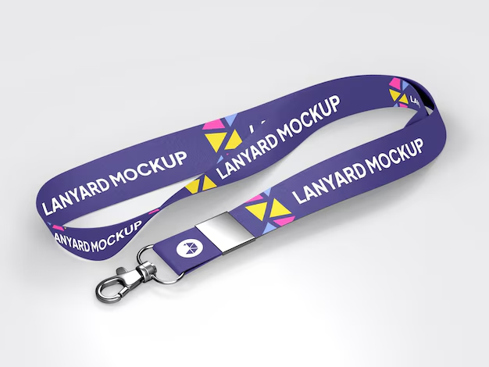 | Piece
10 | Stamp | 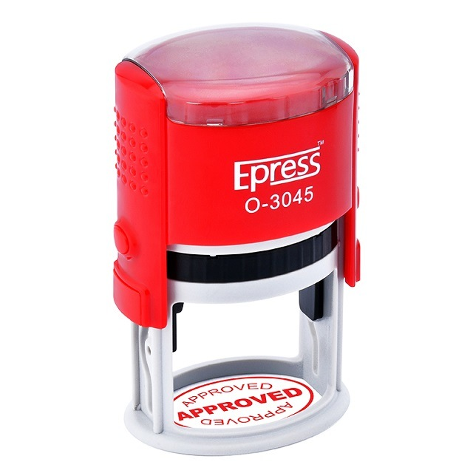 | Piece
11 | Car adhesive logos (A3) | 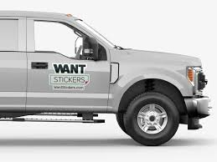 | Piece
12 | Motorbike adhesive logos (A5) |  | Piece
13 | Adhesive logos (A4) |  | Piece
14 | Shaped car adhesive | 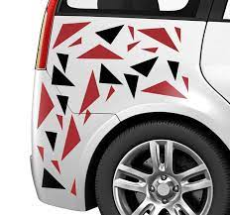 | Piece
15 | T-shirt with printed logos (front and back),  100% cotton, different sizes | 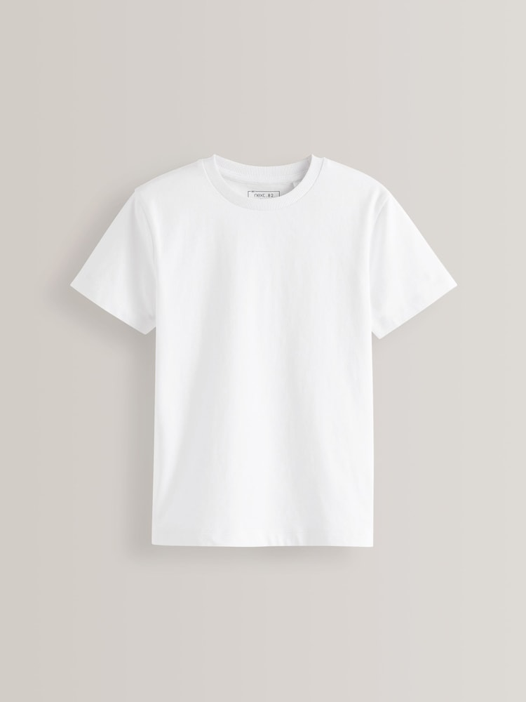  Logo | Piece
16 | Caps with embroidered logo,  100% cotton, different sizes |   Logo | Piece
17 | Polo shirt short sleeves with embroidered logo front and printed logos back,  100% cotton, different sizes | 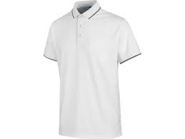  Logo | Piece
18 | Polo shirt long sleeves with embroidered logo front and printed logos back,  100% cotton, different sizes | 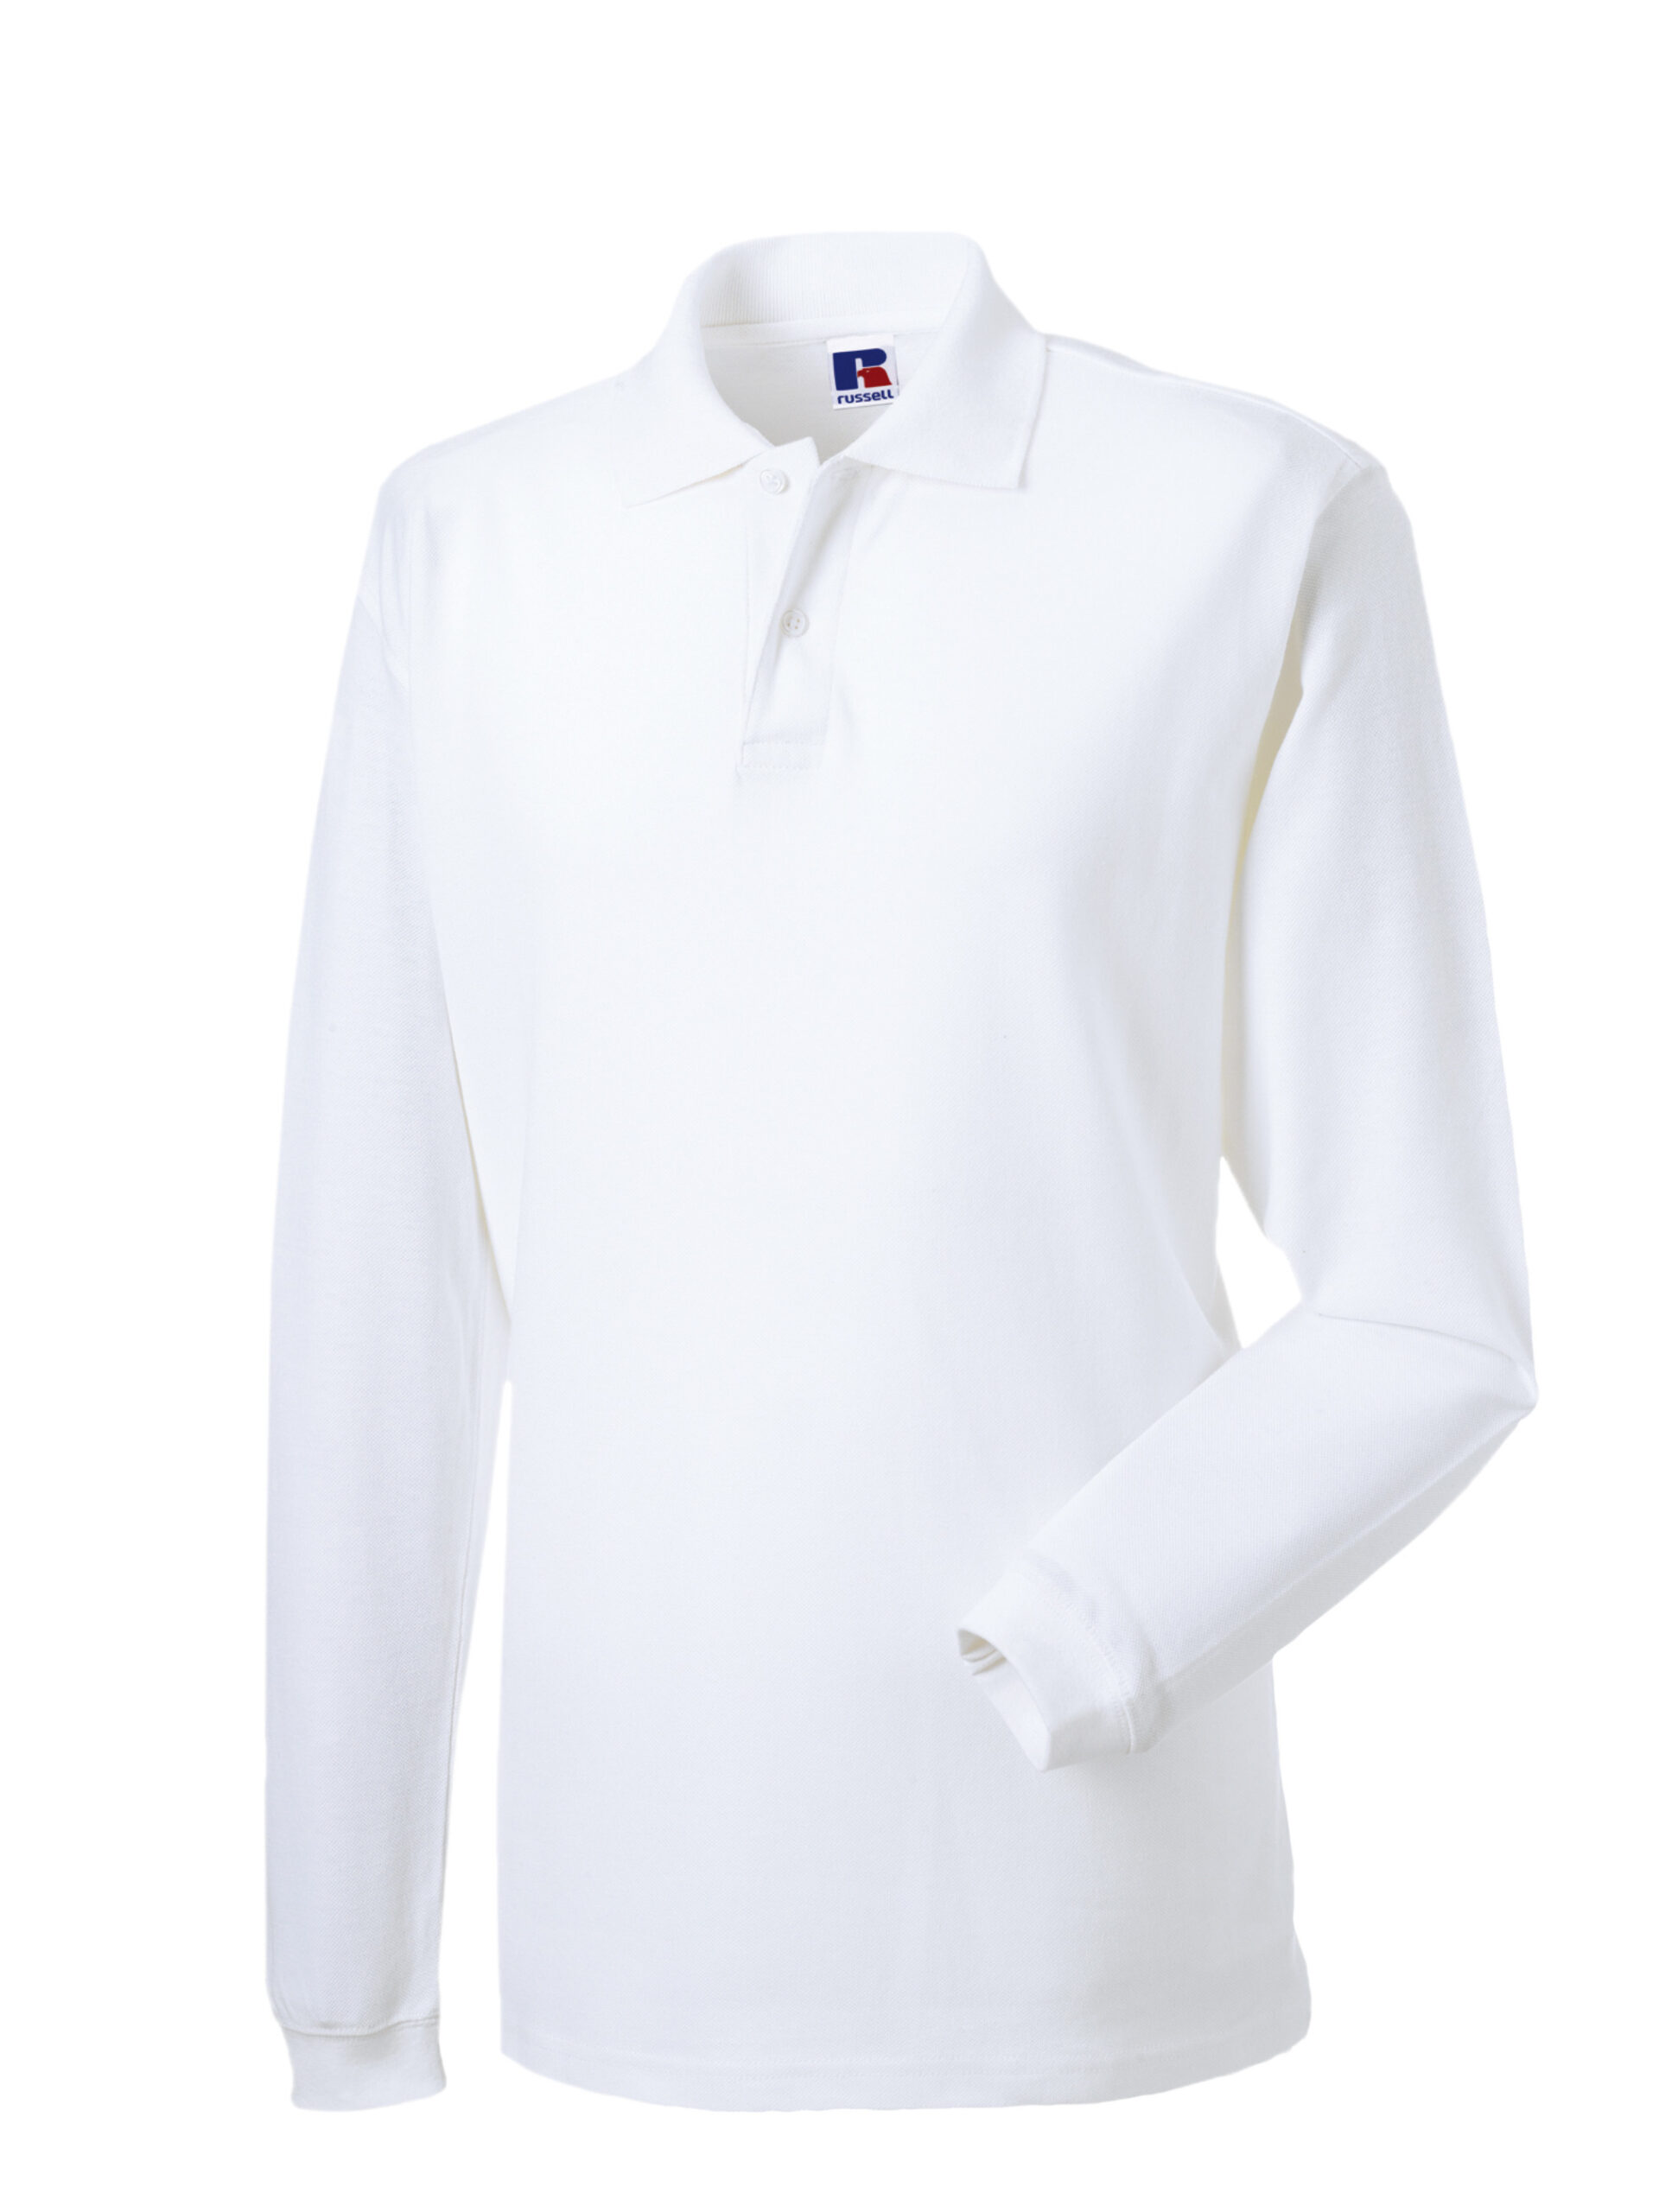  Logo | Piece
19 | Vest sleveless with pokets with embroidered logo front and printed logos back,  100% cotton, different sizes | 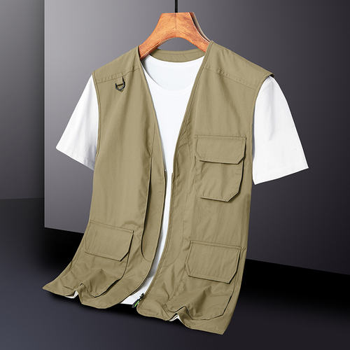 | Piece
20 | Jacket with embroidered logos | 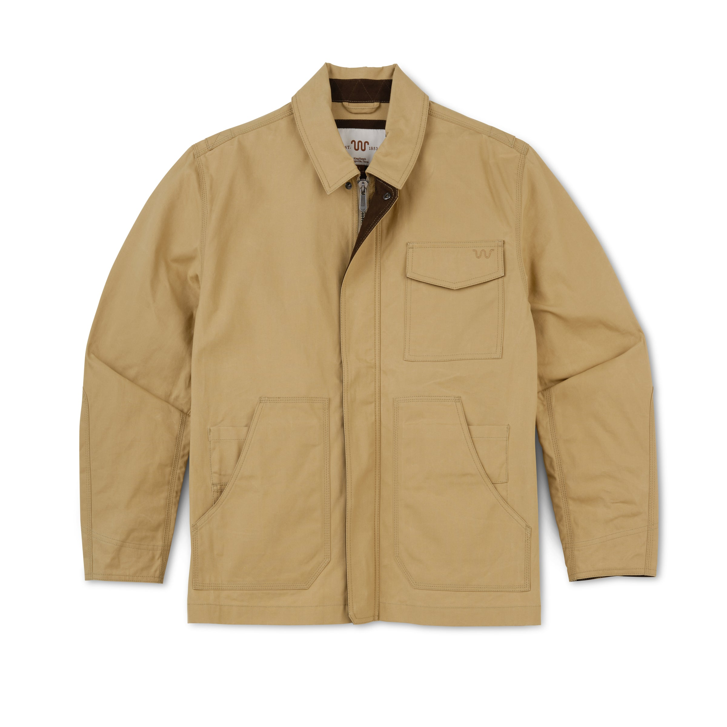 | Piece
21 | Backpack with logos | 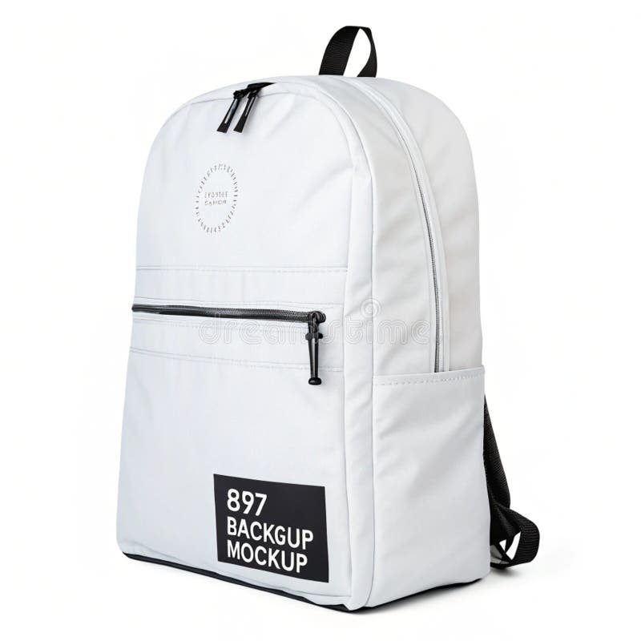 | Piece
22 | Backpack with logos  waterproof |  | Piece
23 | Computer bag with logos | 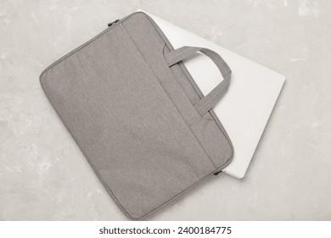 | Piece
24 | Tote bag with logos | 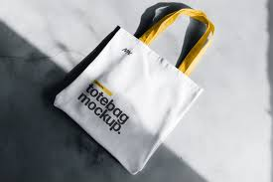 | Piece
25 | Water bottle with logos | 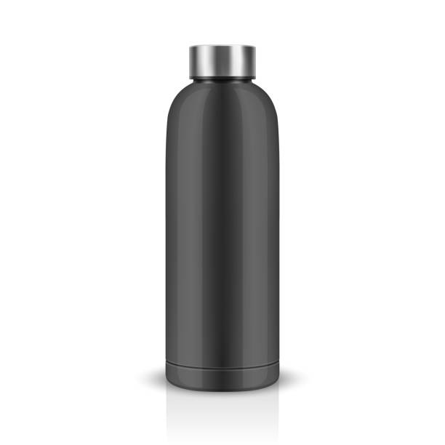 | Piece
26 | Rain jacket | 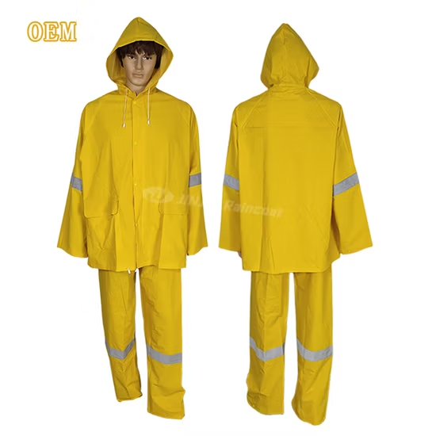 | Piece
27 | Rain trouser |  | Piece
28 | Rain poncho | 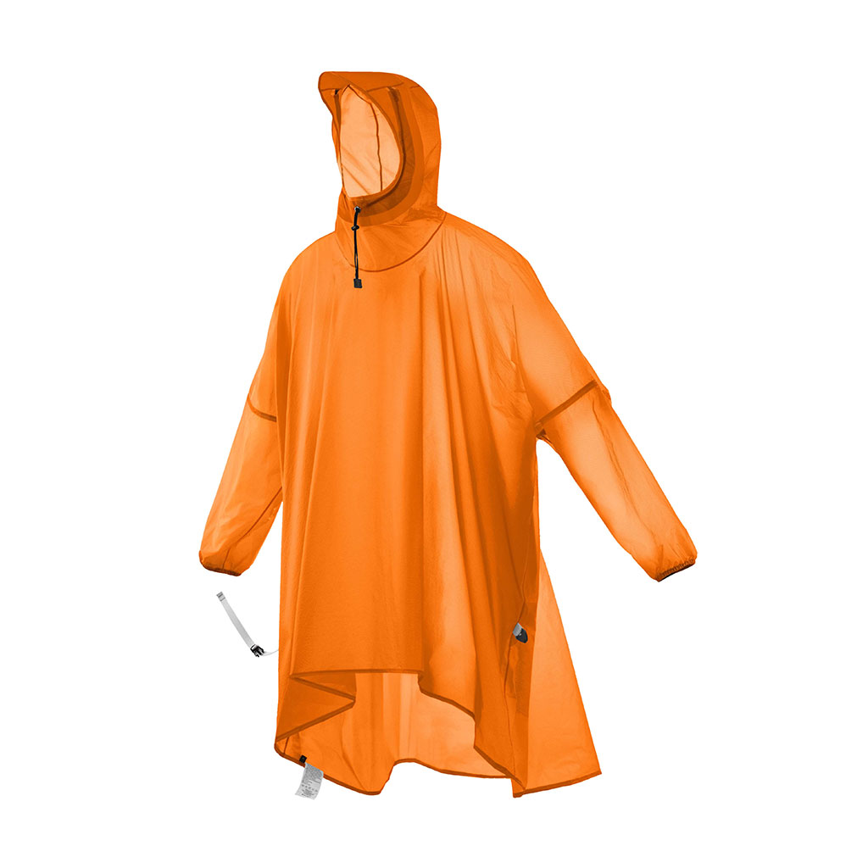 | Piece
29 | First aid kit with logo | 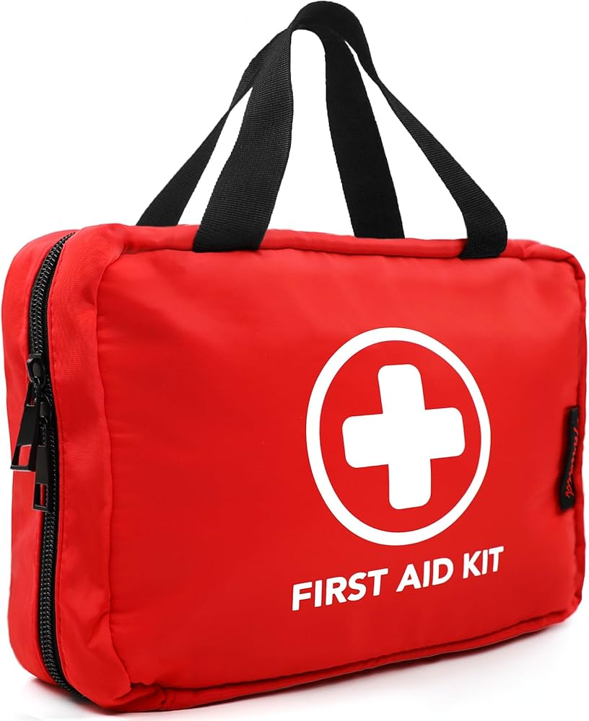 | Piece
30 | Poster 80x60, Rigid | 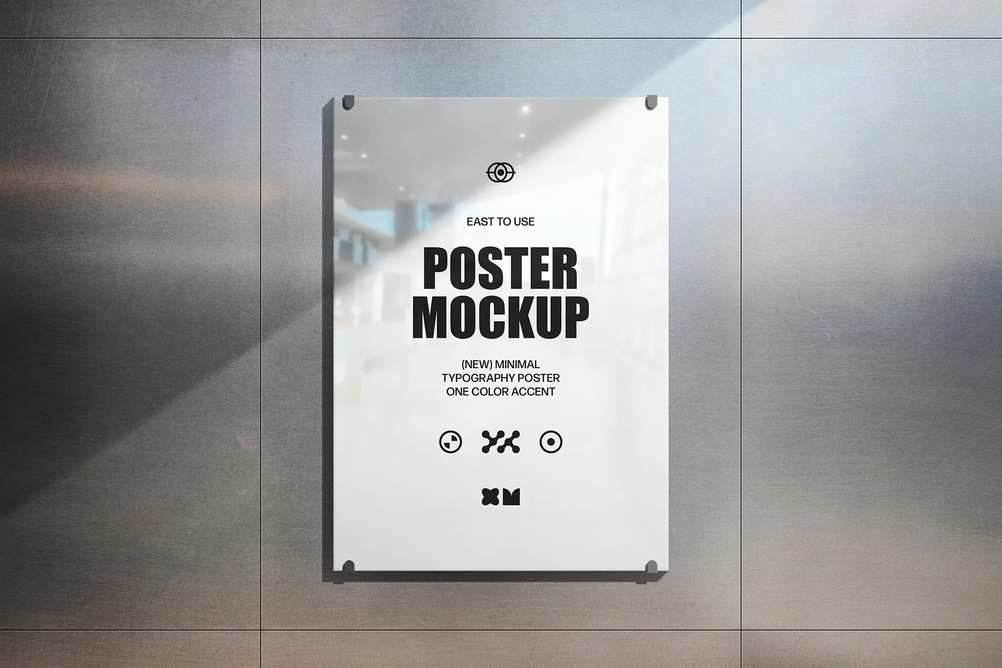 | Piece
31 | Poster 160x120, Rigid |  | Piece
32 | Booklet A5 (20-100 pages) | 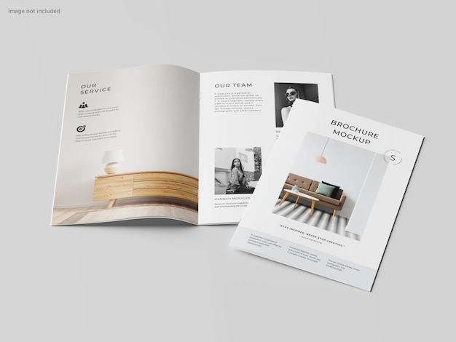 | Piece
33 | A4 three-fold flyer brochure |  | Piece
34 | A4 plastic bound handbook (20-100 pages) | 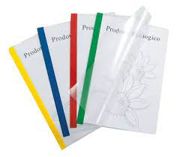 | Piece
35 | A4 plastic bound handbook (100-300 pages) |  | Piece
36 | A4/A5 paper hardcover handbook (20-100 pages) |  | Piece
37 | A4/A5 paper hardcover handbook (100-300 pages) |  | Piece
38 | A4 plastic spiral bound handbook (20-100 pages) |  | Piece
39 | A4 plastic spiral bound handbook (100-300 pages) |  | Piece
40 | Notepad with logos | 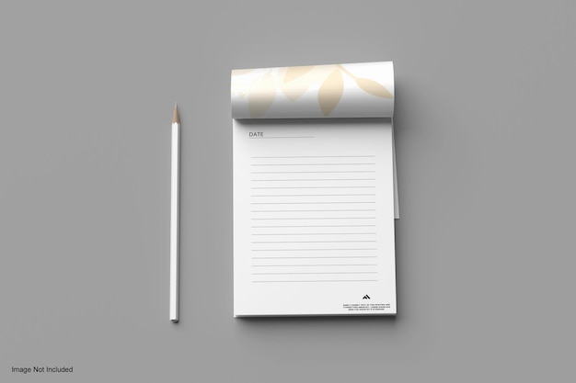 | Piece
 | DELIVERY TIME FROM THE ORDER |  |  |  |  |  |  | Days | 2
 | DELIVERY QUANTITY AT THE ORDER |  |  |  |  |  |  | % | 100
 | VALIDITY OF THE QUOTATION |  |  |  |  |  |  | Days | 40

Done at: by

_______________________
Stamp and signature

