ANNEX II + III: TECHNICAL SPECIFICATIONS + TECHNICAL OFFER

Contract title: Stationery Supply p 1 /…
Publication reference: <04/2026/AID013244.12.2 >

Columns 1-4 should be completed by the contracting authority
Columns 5-8 should be completed by the tenderer
Annex III - the contractor's technical offer
The tenderers are requested to complete the template on the next pages:
- Column 2 and 3 are completed by the contracting authority and show the required specifications (not to be modified by the tenderer),
- Column 5-7 is to be filled in by the tenderer and must detail what is offered (for example the words ‘compliant’ or ‘yes’ are not sufficient)
- Column 8 is to be filled in by the tenderer and must detail the financial offer
The eventual documentation supplied should clearly indicate (highlight, mark) the models offered and the options included, if any, so that the evaluators can see the exact configuration. Offers that do not permit to identify precisely the models and the specifications may be rejected by the evaluation committee.
The offer must be clear enough to allow the evaluators to make an easy comparison between the requested specifications and the offered specifications.

Financial & technical offer

NAME OF THE SUPPLIER:

Pos. | Description of Items | Technical specifications required | Preferred Unit Measure | Unit Measure offered by Supplier | Type of packaging  (box, ream, pack, bag, single piece...) | Quantity contained in each packaging-unit | Financial offer for packaging-unit (USD)  Unit cost with delivery DDP
1 | Transparent Glue  21gr | 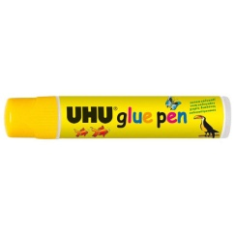 | Box 24 pieces
2 | Erasing Pen |  | Piece
3 | Hole Puncher – Large  For 25 sheets | 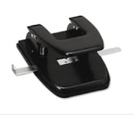 | Piece
4 | 2 Rings Document folder – large  Clipp binder | 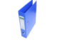 | Piece
5 | 2 Rings Document folder – slim | 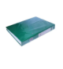 | Piece
6 | Pad (for stamp) | 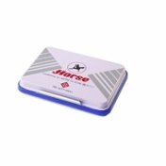 | Piece
7 | Ink for Pad | 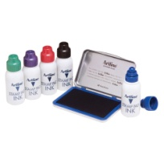 | Bottle
8 | Stapler Small  No.10 | 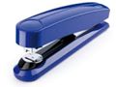 | Piece
9 | Staples Pins Small  No.10 | 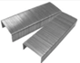 | Box 10,000 pcs
10 | Stapler Medium  No.16 | 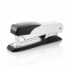 | Piece
11 | Staples Pins Medium  No.16 |  | Box 10,000 pcs
12 | Pin Remover |  | Piece
13 | Ballpoint Pen - Black, blue, red | 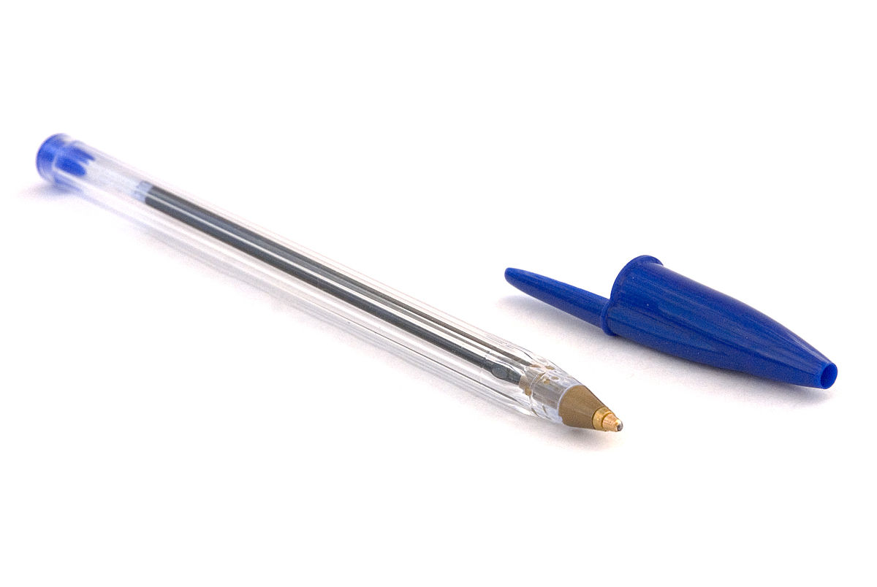 | Box 50 pcs
14 | Gel Pen – Black, blue, red | 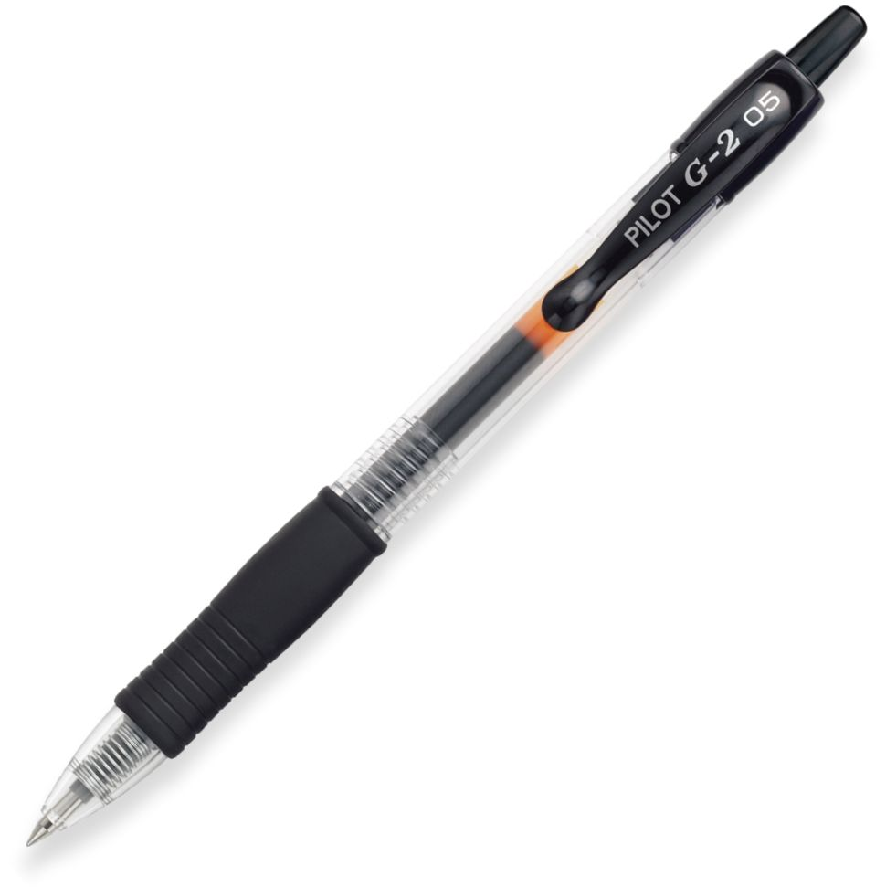 | Box 4 pcs
15 | Rollerpoint Pen – Black, blue, red | 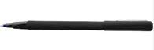 | Box 4 pcs
16 | A4 Plastic Sheets Protectors (100 Pcs) | 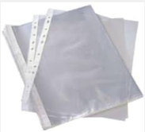 | Package 100 pcs
17 | Notebook A5  Hard cover | 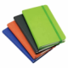 | Piece
18 | Note Book A4  Soft cover, Saddle stitch binding | 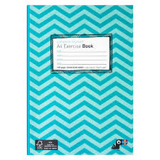 | Package of 12 pcs
19 | Note Book A5  Soft cover, Saddle stitch binding | 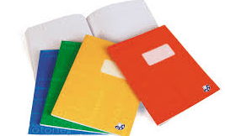 | Package of 12 pieces
20 | Note Pad A5  Upper binding |  | Package of 12 pieces
21 | Adhesive label maker | 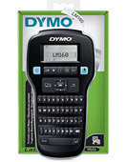 | Piece
22 | Label roll for adhesive label maker  3m | 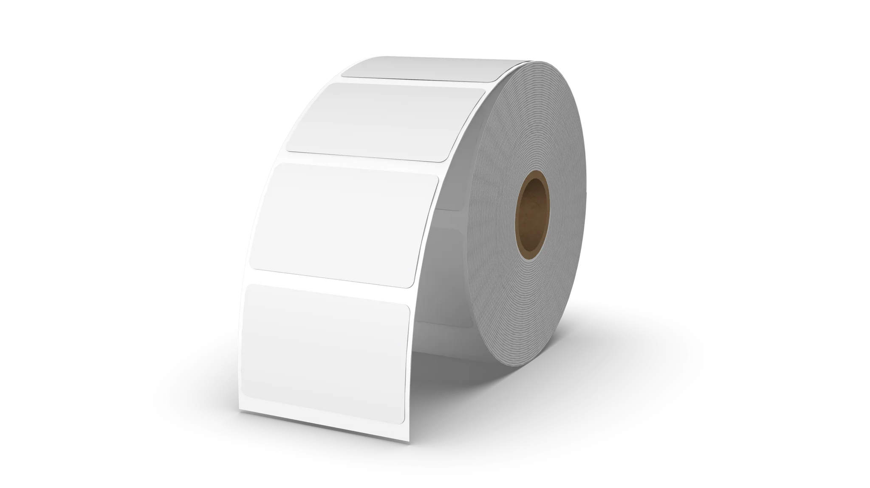 | Piece
23 | Eletronic Calculator | 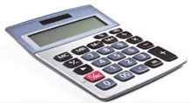 | Piece
24 | Battery Size AA 1,5V | 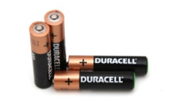 | Packet
25 | Battery Size AAA 1,5V |  | Packet
26 | Button Cell Battery – 20 mm |  | Piece
27 | Ream of paper A4 | 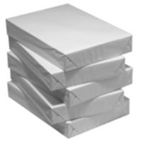 | Ream
28 | Carton of paper A4 | 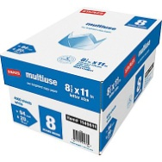 | Carton of 5 pieces
29 | Ream of paper A3 | 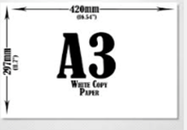 | Ream of 100 pieces
30 | Highlighting pen | 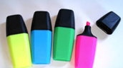 | Box 4 pcs
31 | Envelope A4 |  | Packet/25 pcs
32 | Envelope A5 |  | Packet/25 pcs
33 | Envelope A3 |  | Packet/25 pcs
34 | Cutter | 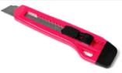 | Piece
35 | Sharper  metal | 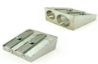 | Piece
36 | Sticky Notes/ Standard Size |  | Packet
37 | Sticky Notes/ Medium-large Size |  | Packet
38 | Block of Receipts | 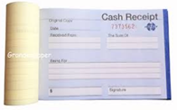 | Piece
39 | Pencil |  | Box of 12 pieces
40 | Rubber |  | Piece
41 | Flip Chart tripoid type | 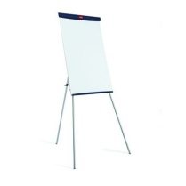 | Piece
 | Flip Chart with wheels | 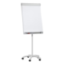 | Piece
42 | Paper for Flip Chart |  | Piece
43 | Permanent Marker Black/Blue/Red/Green | 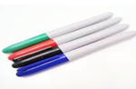 | Box 12 pcs
44 | Erasable Marker for Witheboard – various colours | 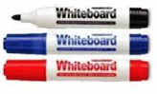 | Box 12 pcs
45 | Transparent Adhesive Tape – Small | 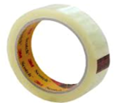 | Piece
46 | Transparent Adhesive Tape – Large | 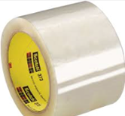 | Piece
47 | BrownAdhesive Tape – Large | 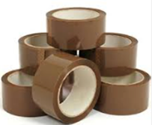 | Piece
48 | Paper Adhesive Tape – Small |  | Piece
49 | Double Side Tape – large |  | Piece
50 | Badge Case | 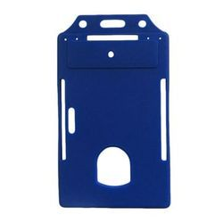 | Packet/5 pieces
51 | Badge String | 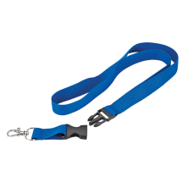 | Packet/10 pieces
52 | Paper Clips – big | 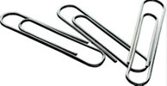 | Box of 100 pieces
53 | Paper Clips – small |  | Box of 100 pieces
54 | Metal Tray 3 tire | 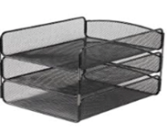 | Piece
55 | Penholder | 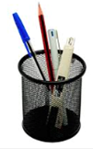 | Piece
56 | Scissors – Big |  | Piece
57 | Scissor – Medium |  | Piece
58 | Erasable Witheboard  120cmx90cm | 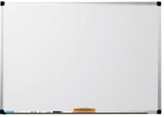 | Piece
59 | Colour markers  felt-tip markers |  | Piece
60 | Whiteboard eraser |  | Piece
61 | Heavy duty stapler  200 sheets | 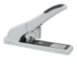 | Piece
62 | Strong glue  3g |  | Piece
63 | Coloured A4 papers  Normal paper | 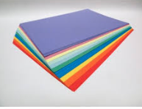 | Ream 100 sheets
64 | Coloured Cardboard paper | 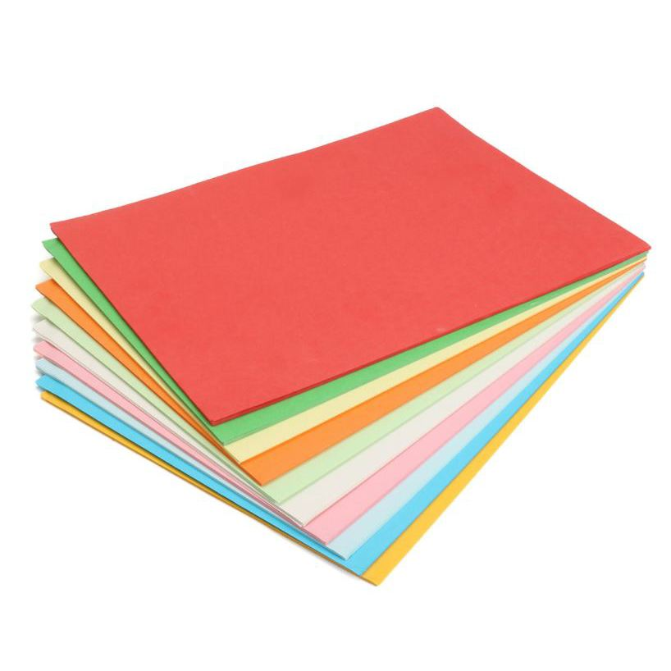 | Ream 100 sheets
65 | Key box | 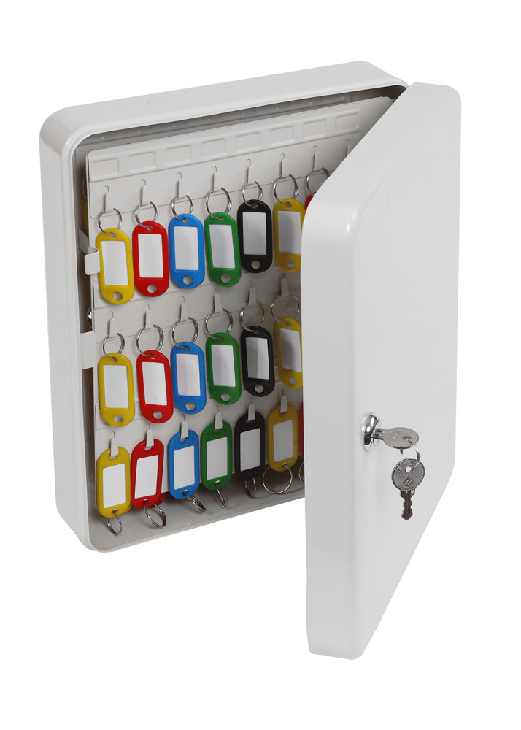 | Piece |  |  |  | /
66 | A4 Laser printer transparency film |  | Package of 100 films
67 | White Envelopes (different types) |  | Package of 100 pieces
68 | Paper cutter (big one)  A4, Metal | 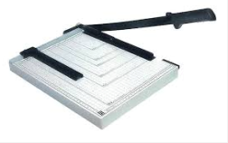 | Piece
69 | Plastic file folders with button |  | Piece
70 | Plastic file folders |  | Piece
71 | Plastic file folders with file fastener | 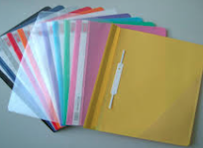 | Piece
72 | Paper file folder |  | Piece
73 | Note Book A4  Spiral |  | Package of 12
74 | Notebooks A5  Spiral | 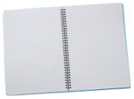 | Package of 12
75 | Adhesive labels |  | Piece
76 | File holder with metal clip | 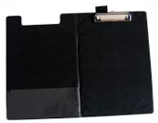 | Piece
77 | Binder clips |  | Box 12 pieces
78 | Paper clips |  | Piece
79 | Clipboard | 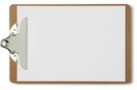 | Piece
80 | Stickers | 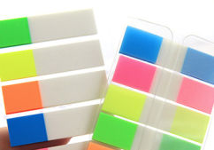 | Package of 100 pieces
81 | Rulers | 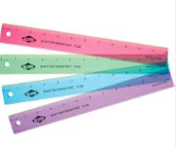 | Piece
82 | Safe deposit box | 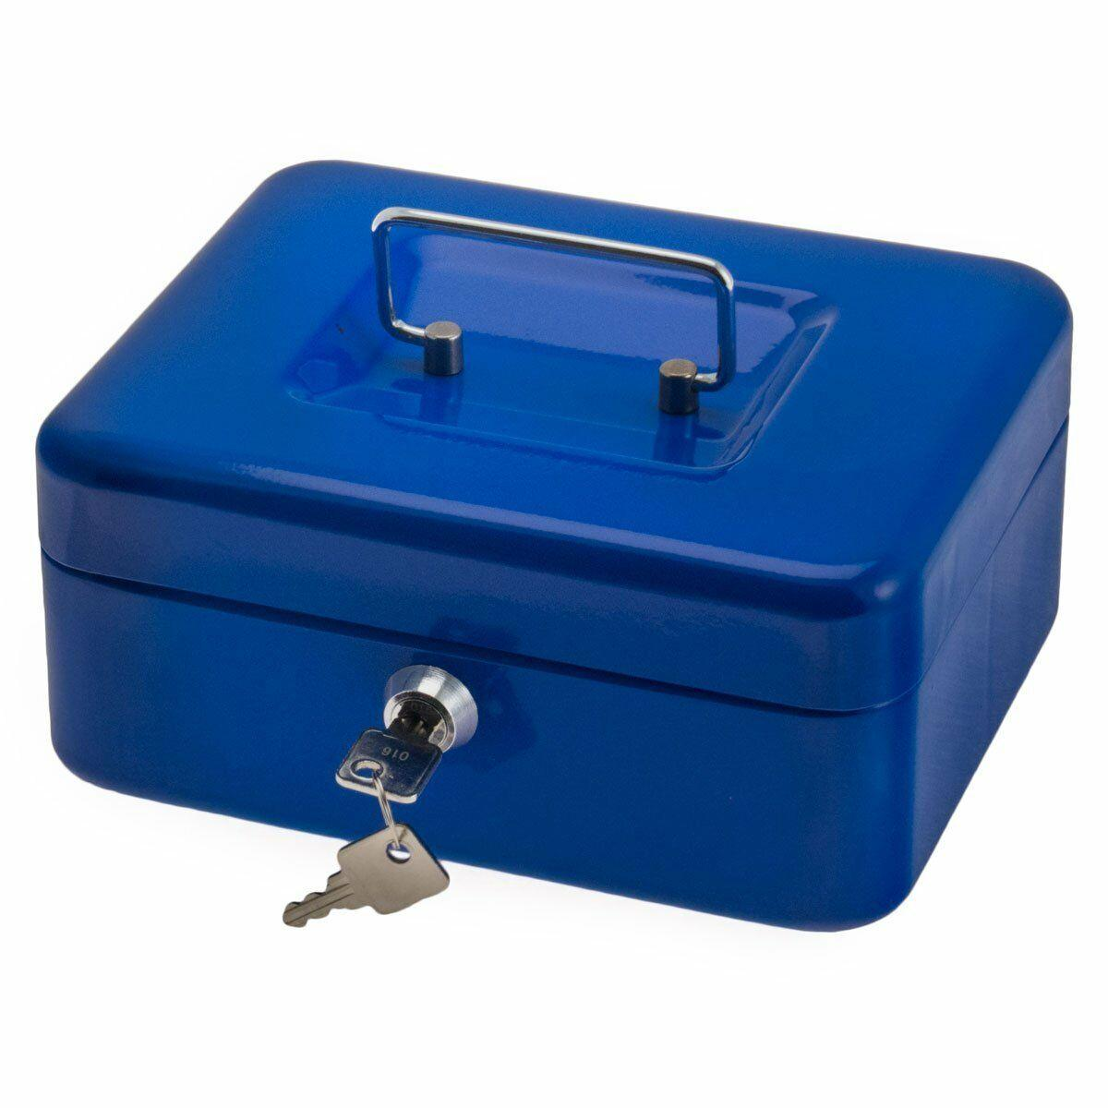 | Piece
83 | Rubber band |  | Package 100 pieces
84 | Spiral binding rings  size: 10mm | 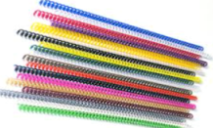 | Package 100 pcs
85 | Spiral binding rings  size: 12mm | 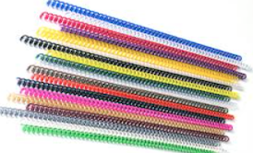 | Package 100 pieces
86 | Spiral binding rings  size: 14mm |  | Package 100 pieces
87 | Spiral binding rings  size: 25mm |  | Package 100 pieces
88 | Laminating pouches A4 |  | Package 100 pieces
89 | ID card laminating pouches |  | Package 100 pieces
90 | Carbon paper | 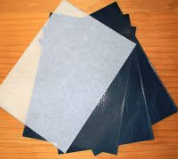 | Package 100 pieces
91 | rubber stamp  Stamp on Order | 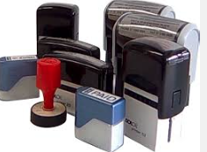 | Piece
92 | Transparent sheets A4 for bookbinder machine |  | Package 100 pieces
93 | Manila sheets for bookbinder machine |  | Pack 100 pieces
94 | Bookbinder machine for plastic spirals | 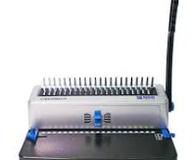 | Piece | PCS
95 | Laminating machine  Heavy duty, metal | 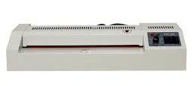 | Piece | PCS
96 | Lables for key holder | 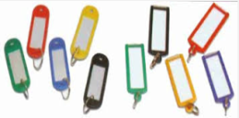 | Piece | PACK of 50 key holders
97 | Coloured Drawing Paper (A1) | 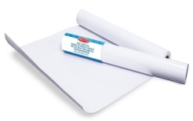 | Piece | PCS
98 | Cards wallet | 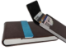 | Piece
99 | Pc cleaner |  | Pieces
100 | Whiteboard magnet |  | Package
101 | Cork Board 90 x 120 cm  90 x 60cm |  | Pieces
102 | Adjustable whiteboard stand |  | Pieces
103 | Plastic Dust bin |  | Pieces
104 | Extension cable  5 ports | 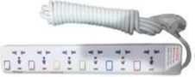 | Pieces
105 | Business card holder |  | Pieces
106 | HP 85A Black Original LaserJet Toner  Cartridge | 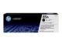 | Pieces
107 | Complete ink set for Brother printer | 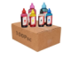 | Set multicolor
108 | Register | 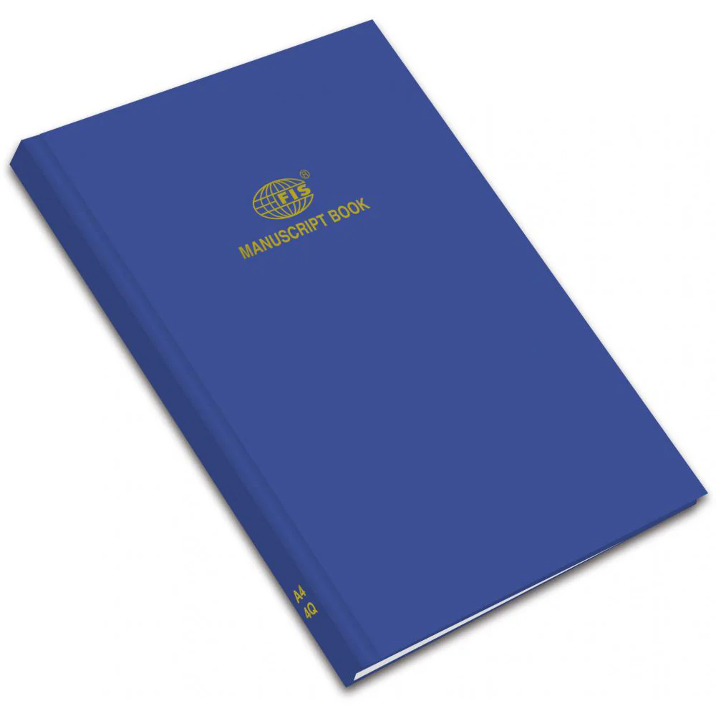 | piece
109 | Visitors Book | 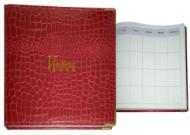 | Pieces
110 | Water bottle – big  18-10 liters | 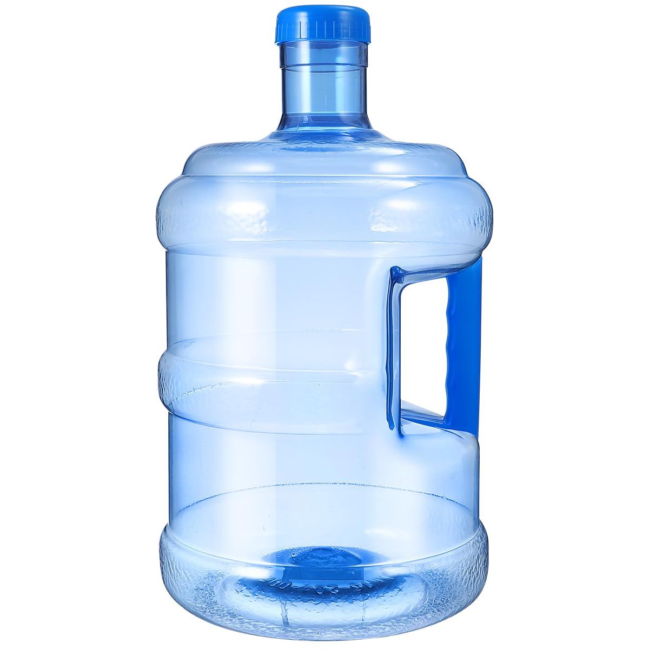 | Piece
111 | Water bottles – small  500 ml |  | Piece
112 | Toilet paper |  | Package of 12 pieces
113 | All-purpose surface cleaner  5 liters | 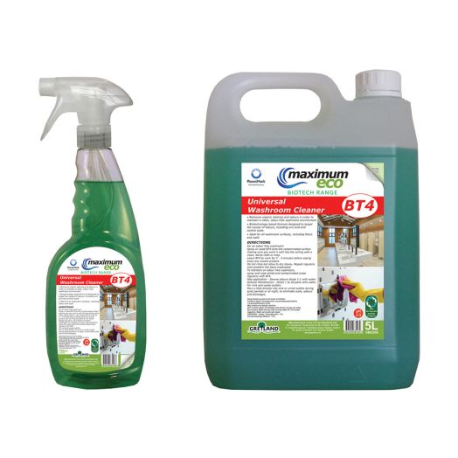 | Piece
114 | Glass cleaner | 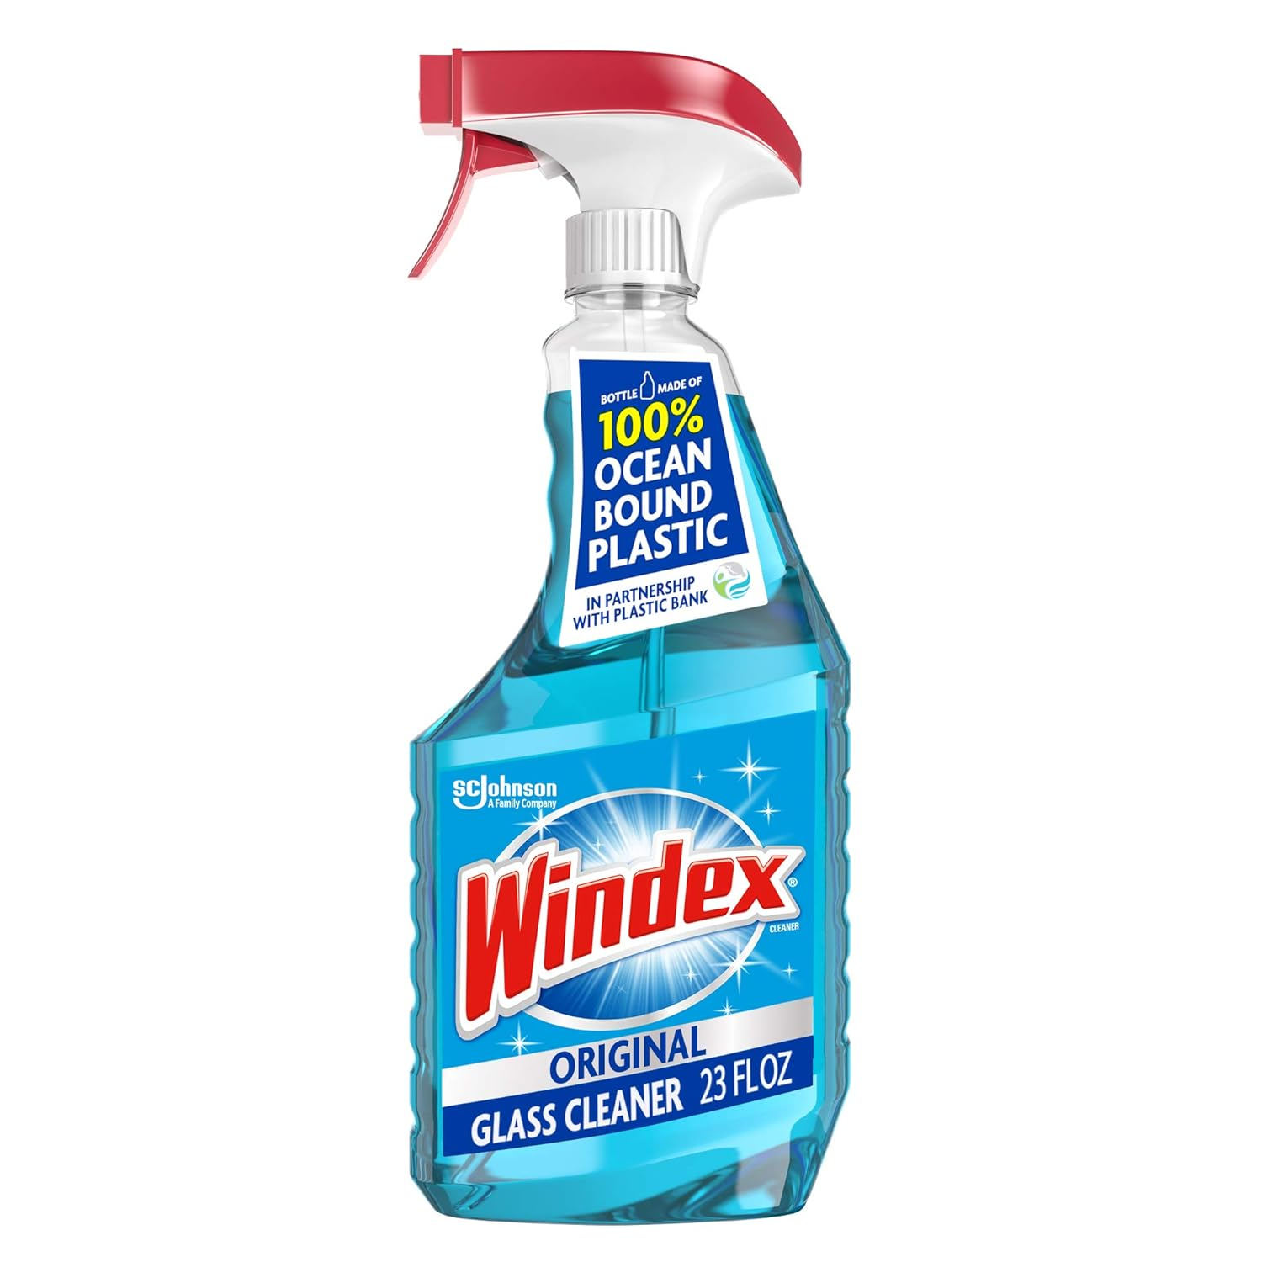 | Piece
115 | Hand soap |  | Piece
116 | Toilet cleaner | 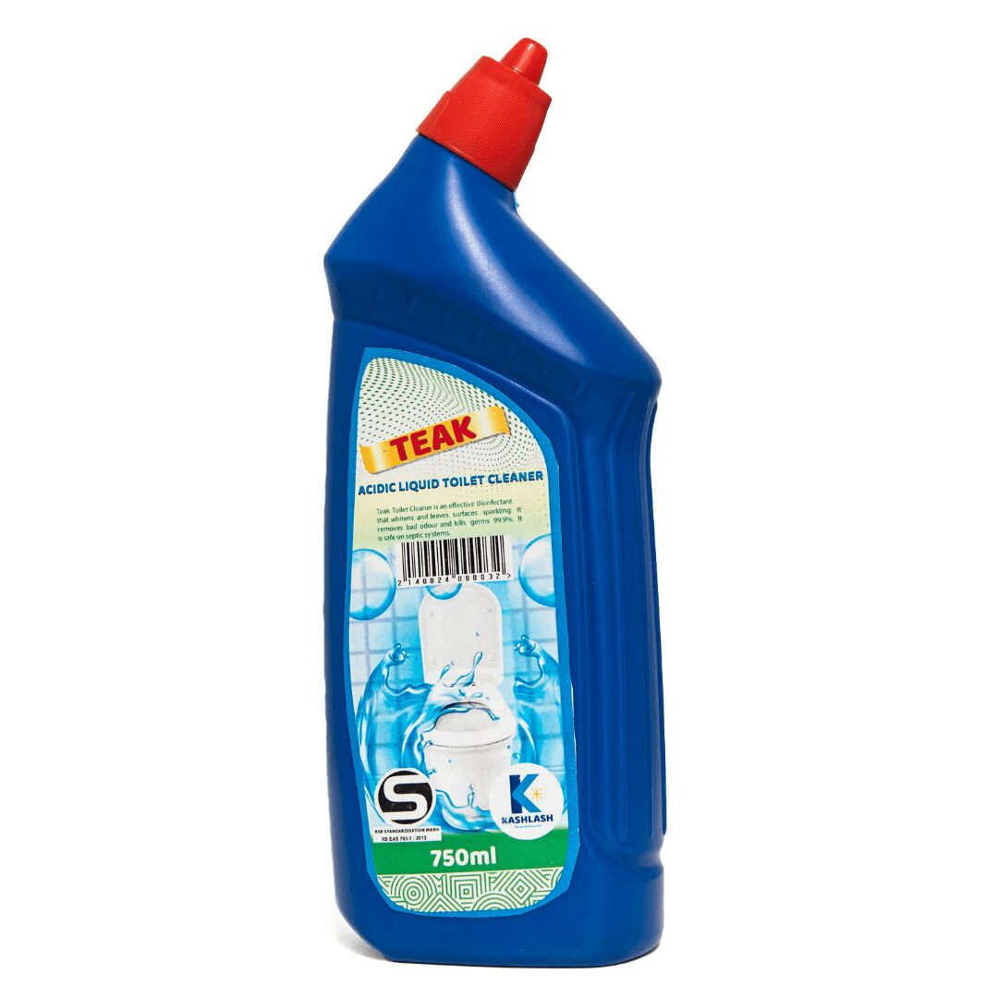 | Piece
117 | Microfiber clothes | 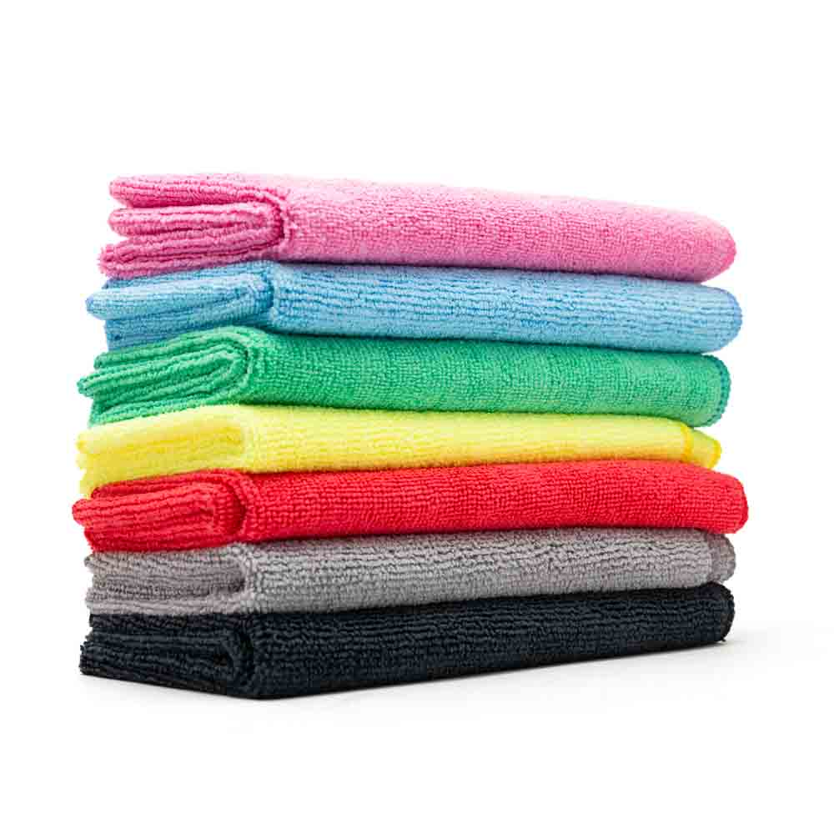 | Package of 6 pices
118 | Broom |  | Piece
119 | Mop | 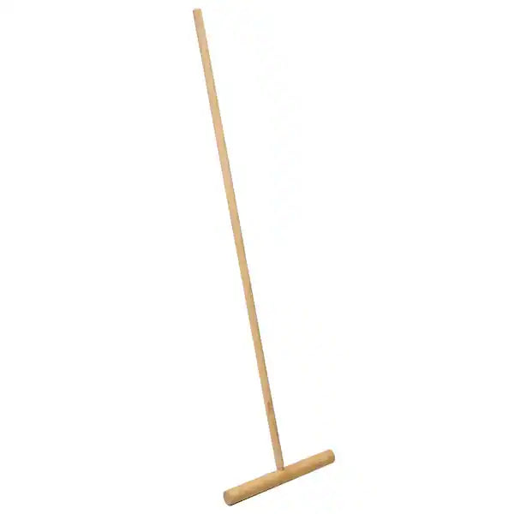 | Piece
120 | Water dispenser | 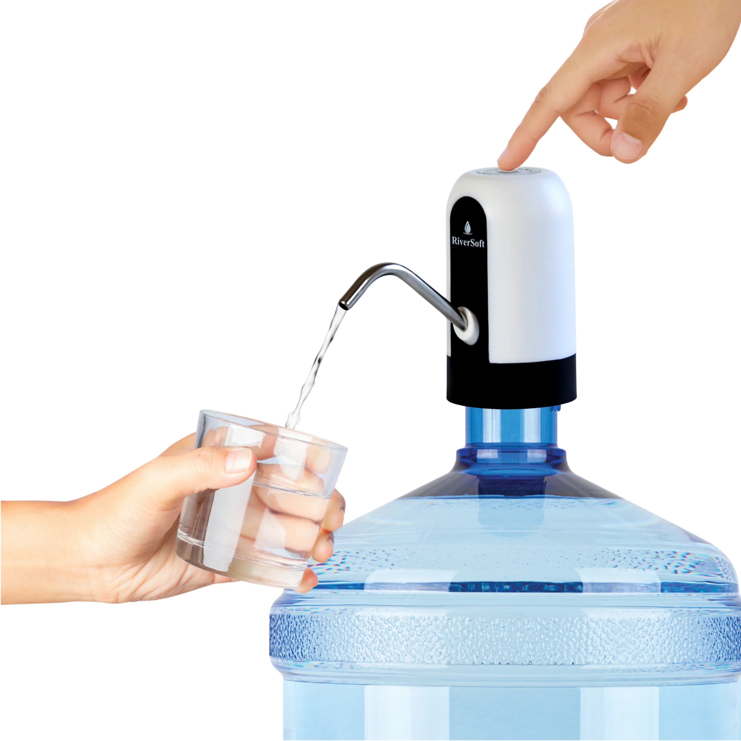 | Piece
121 | Kitchen Napkins |  | Package
122 | Alcohol-based hand sanitizer |  | Bottle
123 | Disposable gloves | 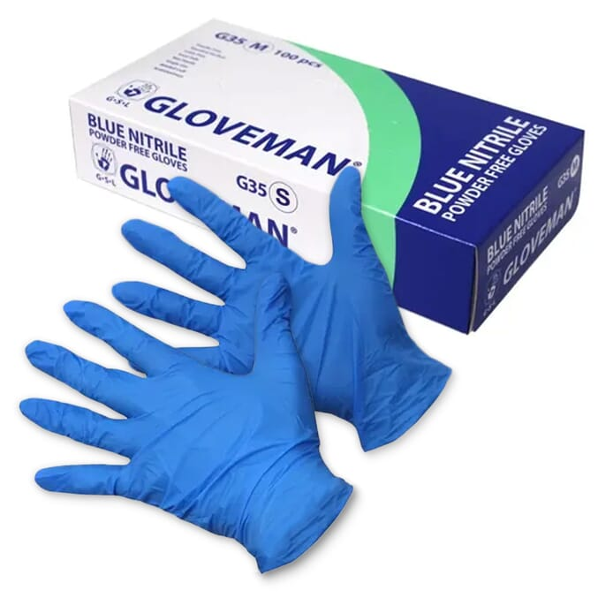 | Box
124 | Waste bins |  | Piece
125 | Toilet brush | 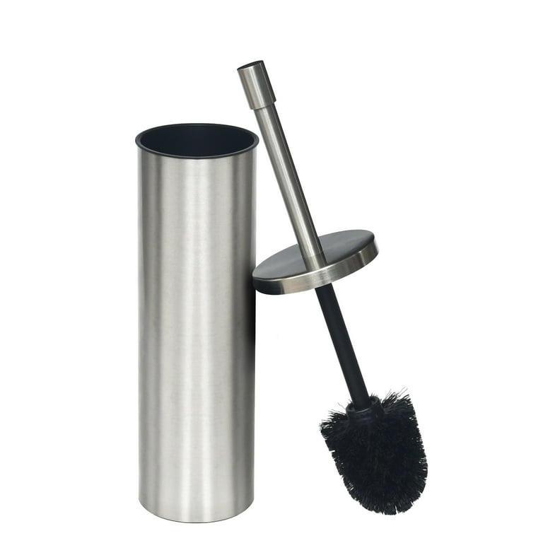 | Piece
126 | Sponges (normal, methalic..) | 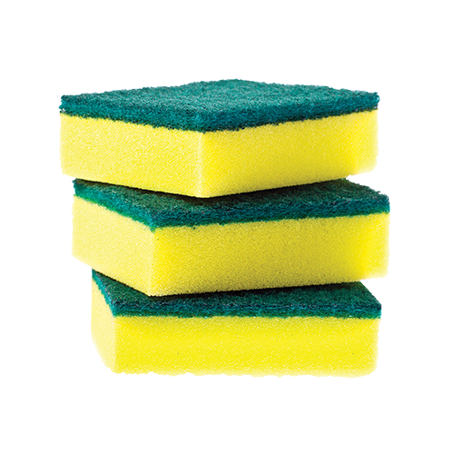 | Package
127 | Bucket | 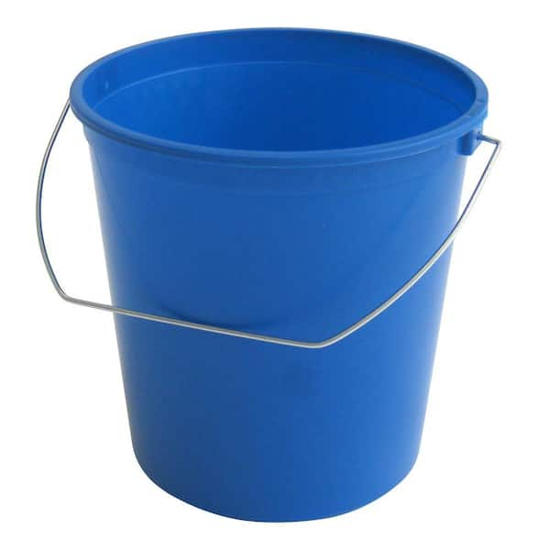 | Piece
128 | Basin |  | Piece
129 | Dish soap |  | Piece
130 | Floor cleaner | 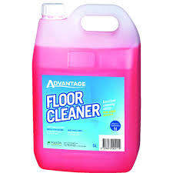 | Piece
131 | Kitchen clothes | 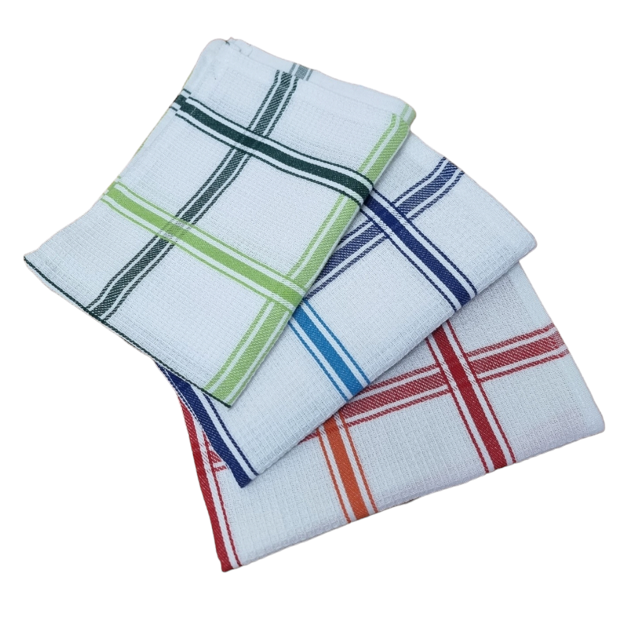 | Package or piece
132 | Floor cleaning rags | 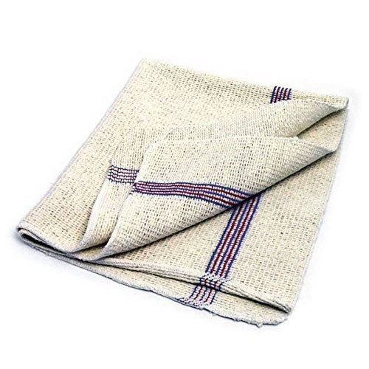 | Package or piece
 | DELIVERY TIME FROM THE ORDER |  |  |  |  | Days | 2
 | DELIVERY QUANTITY AT THE ORDER |  |  |  |  | % | 100
 | VALIDITY OF THE QUOTATION |  |  |  |  | Days | 40

Done at: by

_______________________
Stamp and signature

